**DIGITAL MARKETING**

ASSIGNMENT : 1

|  |  |
| --- | --- |
| Name | Deepika J S |
| Reg no | 960220106045 |
| NM id | 31F3036658BC918A437434DE374F0C54 |
| Team id | NM2023TMIDO2667 |

Create a blog or website using blogspot and Wordpress .Customize the theme design and post new article with 500 words.

**BLOGGER** :

<https://www.blogger.com/blog/post/edit/8926082454665038726/5587026901154525930>

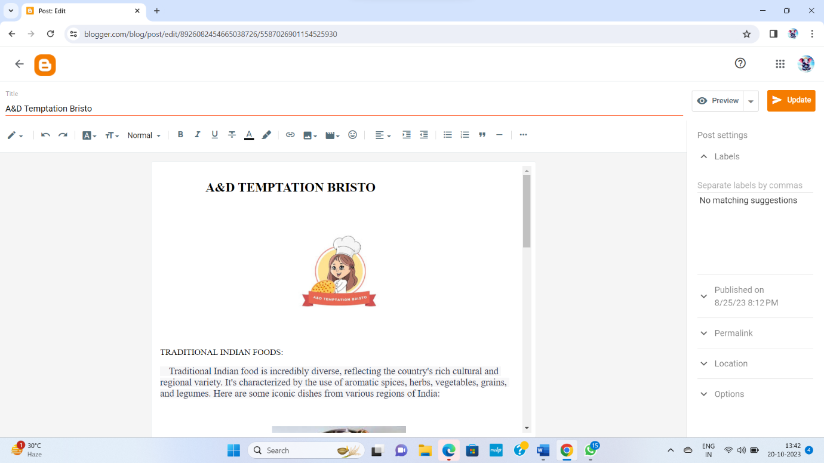

**WORDPRESS** :

<https://deepikajs2259.wordpress.com>

